Link to code: Github

Q1
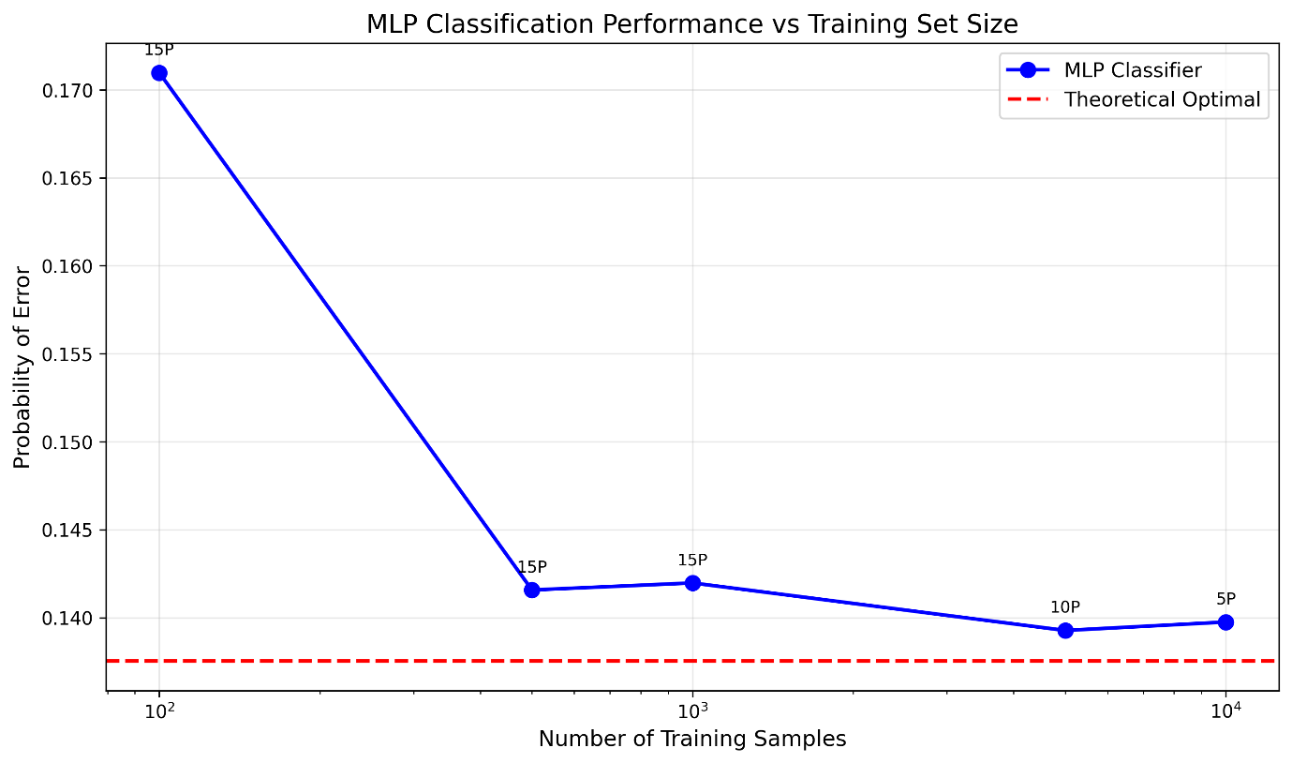
The above figure shows the relationship between Probability of Error and the Number of Training Samples, along with the number of perceptrons used in the hidden layer. To ensure reproducibility of output, random.seed(42) was used. I used scikit-learn’s MLPClassifier and KFold method for cross-validation. The architecture has a total of 3 layers, including: input, hidden, and output layers. The tanh activation function was used as specified in the problem of using a smooth-ramp style function (ISRU, Smooth-ReLU, ELU are not implemented in scikit-learn). Number of perceptrons were [1,2,3,4,5,8,10,15,20] and each of them trained on dataset = [100,500,1000,5000,10000] samples. There are total of 4 classes with uniform distribution, each having own mean and covariance matrices. After training, Kfold cross validation was performed for each value of perceptrons. As the number of training samples increased, the simpler model could learn about the data.
No. of Samples | No. of perceptrons | P(Error) rate
100 | 15 | 0.170970
500 | 15 | 0.141570
1000 | 15 | 0.141970
5000 | 10 | 0.139270
10000 | 5 | 0.139750

Theoretical Error rate came at 0.137530 (13.75%)

Q2
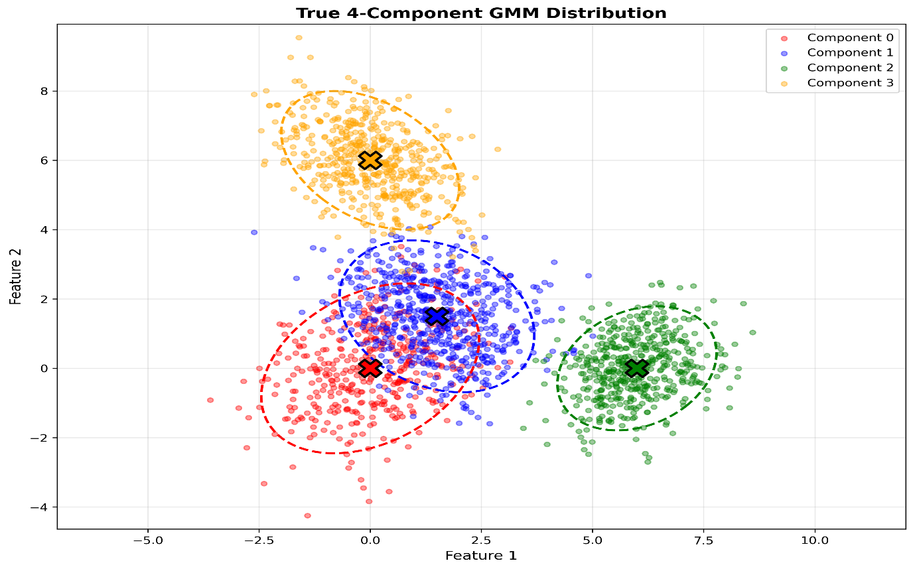

Two components of GMM overlap significantly, as shown above. Generated datasets with 10, 100, 1000 samples. For each dataset, 10-fold cross-validation was performed for GMM components from 1 to 10. This was performed 100 times, and the image below shows the selection rate for various components.
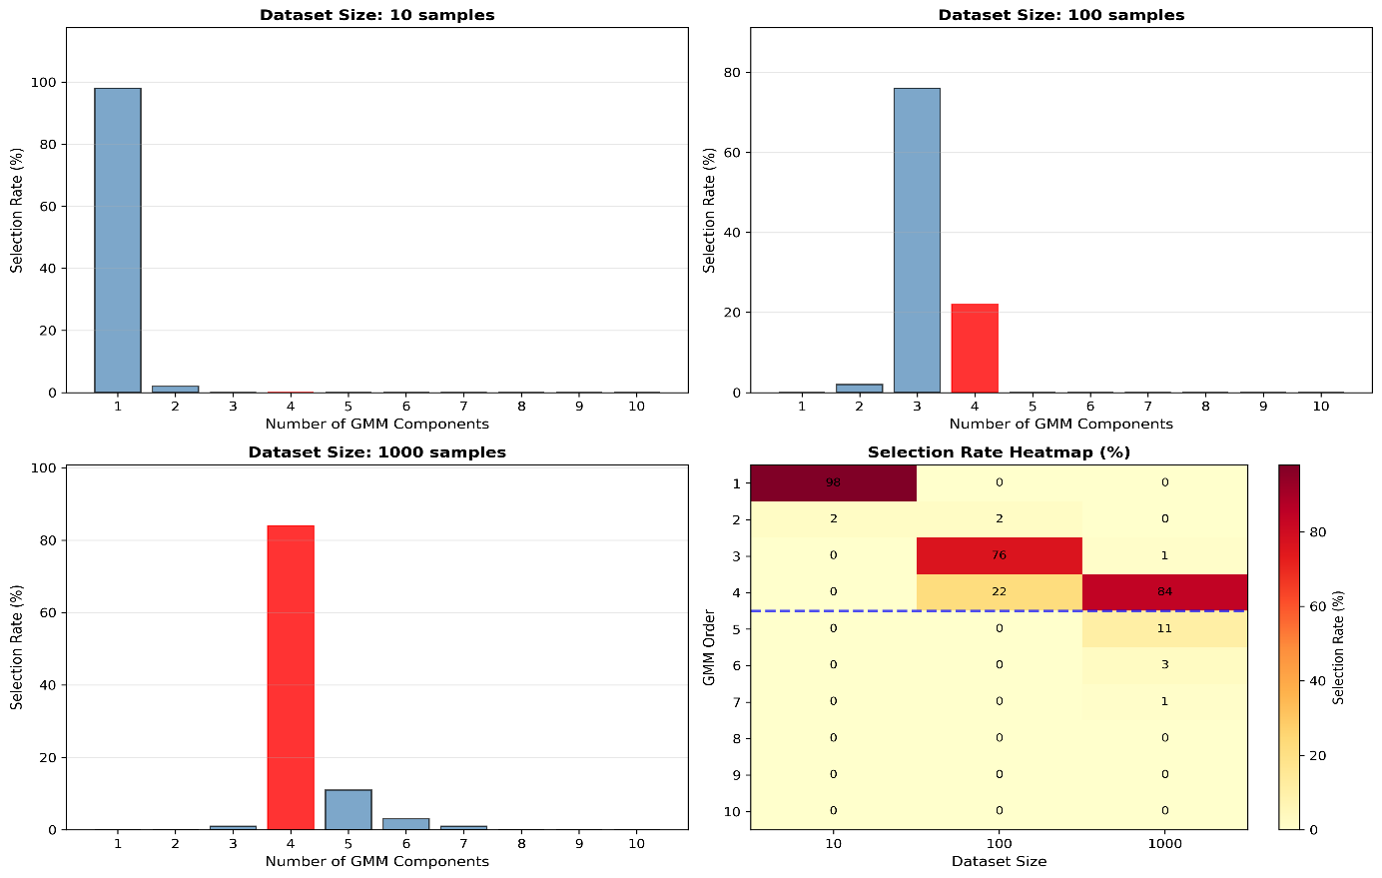
As the dataset size increases, model selection accuracy improves dramatically, shifting from severe underfitting (1 component) to accurate identification (4 components). This demonstrates that more data enables the detection of more complex patterns (from 0% selection rate for 10 samples to 84% time for 1000 samples for 4 components).

References
https://www.geeksforgeeks.org/machine-learning/activation-functions-neural-networks/

